Document Browser for Blind

Ankit Bagde - 17CS30009
Naimesh Pramanik - 17CS300023

Table of contents:
_{Introduction}
- Purpose or need for the project?
- _{Intended Audience}
_{Overall Description}
- Existing solutions for blind/visually impaired people
- _{Our approach to the problem!}
- What are the challenges to be overcome while developing the system?
_{System Features}
- _{Functional Requirements}
- _{Non-Functional Requirements}
_{UML Diagrams}
- _{Use Case diagram}
- _{Sequence Diagram}
- _{Class Diagram}
_{References}

Introduction

Purpose or Need for the project?
- Blind or visually impaired people face a lot of difficulties while browsing internet.
- There is a need for such software which can be user-friendly to blind or visually impaired people so that they can browse without much difficulty.

Intended Audience
- This software is helpful for several classes of people ranging from partially blind to such people who are completely blind. Any visually impaired individual can browse internet with help of this software.

Overall Description

Existing solutions for blind/visually impaired people
Solutions to the problem of web accessibility fall into one of four categories:
- Reliance on a conventional web browser and a screen reader
- Utilizing the accessibility features of HTML and existing web clients
- Using trans coding proxy servers to convert web-page HTML into a more accessible format
- Using a dedicated web browser.
For more details on existing solutions click here and follow onwards page 4.

Our approach to the problem!
- Our approach to the problem will be basically the development of a voice driven web browser.
- Some particular keys will be allotted to users through which they can control the software i.e. Number keys and enter key.
- Text to speech and Speech to text recognition techniques will be used.
- The browser will google search for the text and will read the output, it will then ask for input to navigate to a particular link. After navigating, it will read out the details of HTML web page on demand of the user.

What are the challenges to be overcome while developing the system?
- If we talk regarding the screen reader method then the problem with this approach is the inaccessibility of content displayed by the browser and the complexity of the user interface. The resulting control interface can be, as noted, very complex.
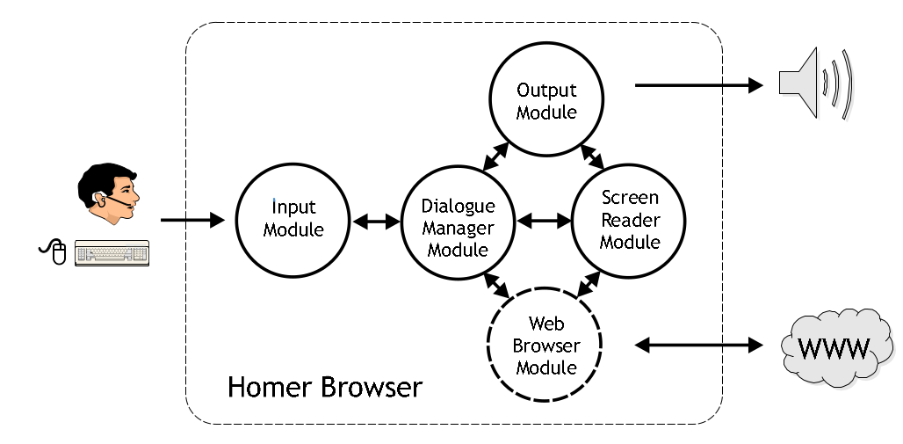
- Some screen readers use the document tree (i.e., the parsed document) as their input. However, older screen readers make use of the rendered version of a document, meaning that document order or structure may be lost (e.g., when tables are used for layout) and their output may be confusing.

Simple model of voice driven browser for blind

- Typically our aim is to render the content of a webpage as a text-only flat document and permit the user to access this accessible content using their normal assistive technology, typically a screen reader.

System Features
Functional Requirements
- Input from user will be taken in the form of the voice which can be converted to string. Our software can recognize certain keywords. A button(probably a key) may be used to activate input command. For e.g.
    - Back page – Go to back page.
    - Repeat – Commanding system to read the text again.
Many such simple keywords will be used by the software to activate certain commands.
- To read webpages correctly, web scraping technique will be used which may be useful to extract well amount of data from simple webpages. Through JavaScript Window Location we may also extract the current page address (URL).In python bs4 will be used to extract the data form a given web page.
- After the Google search is being done after the conversion of speech into string, the software will read out all the search links that are there in the page. The Software relates each search result with a particular number. On selecting the particular number will select the corresponding link and proceed to read the link further.
- After data extraction from a particular webpage we will ask user to give input over what he may like to listen about the web page.
- Head – Software will read head tag.
- Body – Software will read body tag.
- Title - Software will read the title of the page.
- Tables – Software will read the elements in the tables that are present in the page.(html_table_extractor lib is used for this)
- Bold – Software will read all the words in the page that are having Bold font.
- Links – Software will read out the links that are in the page.
- Paragraph – Software will read out the paragraph.
Similarly, other specified keywords will be used to enable the reading of a particular tag.

Non - Functional Requirements
- Performance & Usability – The software is easy to learn as it contains few obvious keywords for the user to memorize. For e.g. back page, repeat, refresh, etc. It will not take much efforts for the user to learn the software. If we talk regarding efficiency of the software as we have chosen a specific term for a particular action, the output will be accurate.
- Adaptability & Scalability - The software is browser dependent, so it doesn’t depend on the operating system that is being used.
- Robustness - In case of incorrect input, the software will ask the user to speak again. In such cases, if the user falls under the category of partially blind people than he/she may use the chrome shortcuts to access the command. Being in its beta phase, the current software may not tackle complex pages in scrapping paragragh.

UML Diagrams

- Use Case diagram:
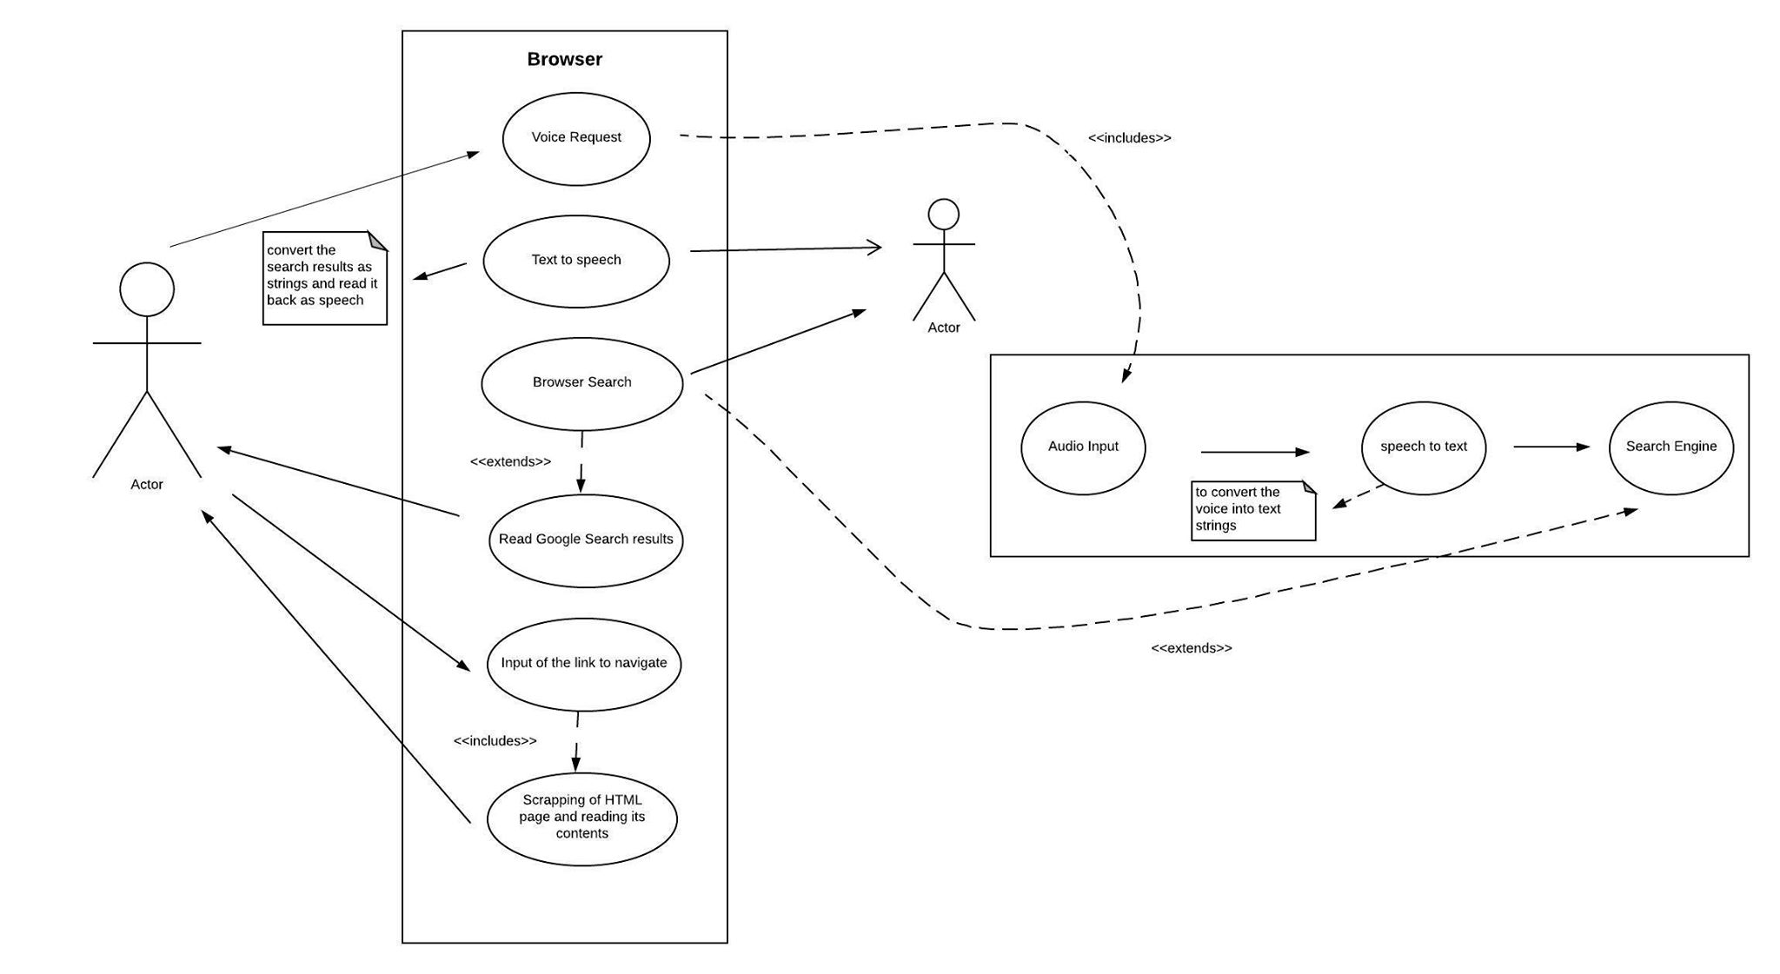
- Sequence Diagram
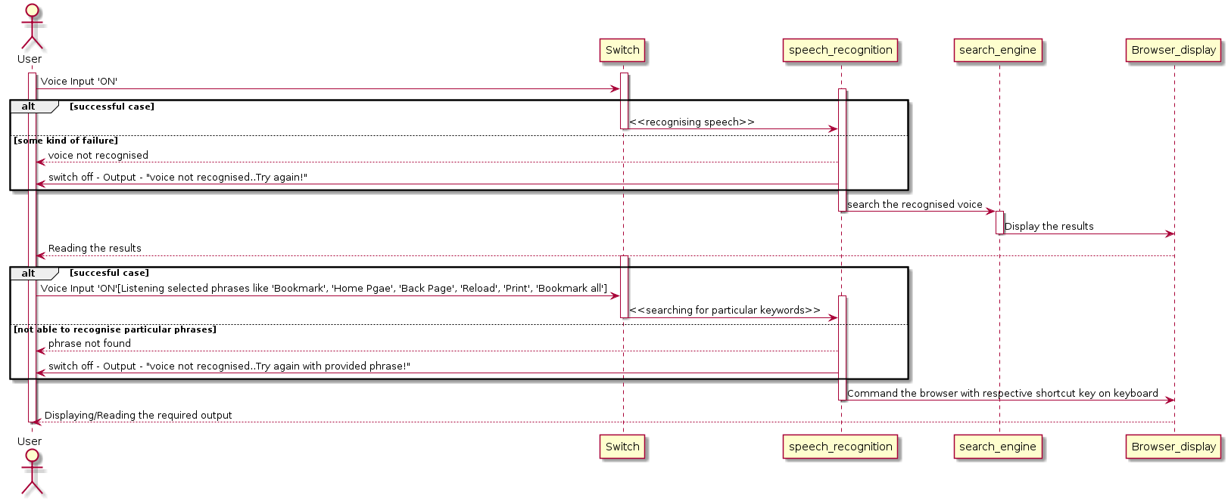

- Class Diagram
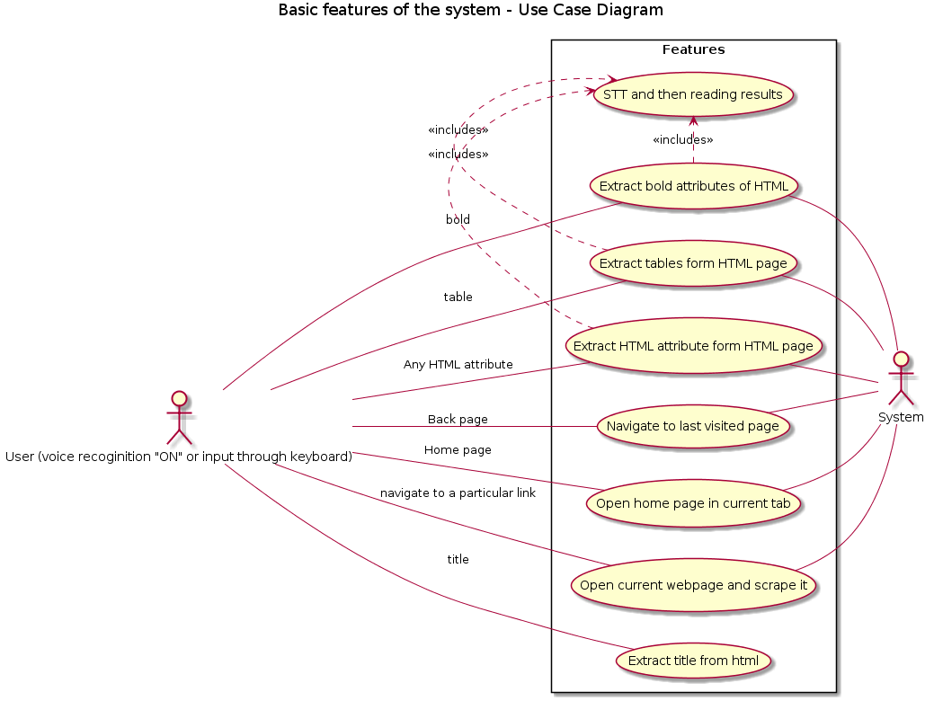
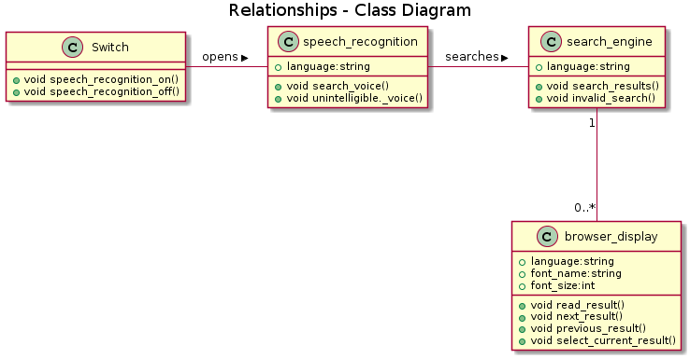

References
References are made from the following documents :
- www.researchgate.net/publication/221481294_A_voice-driven_web_browser_for_blind_people
- https://pdfs.semanticscholar.org/cd19/33070b4333a28b122741a51325ff3ae5075d.pdf

